Digestive System
Part 1: Mouth
Teeth:
Saliva:
Esophagus:

Part 2: Stomach & Small Intestines
Small Intestine:

Digestive Enzymes:

Part 3: Liver, Gallbladder, and Pancreas
Liver:

Gallbladder:
Pancreas:

Excretory System
Parts:
Colon:

Cecum:
Kidneys:

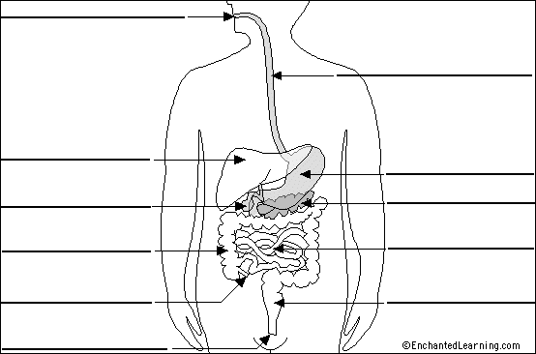

Ways to Take Care of Your Digestive System

1.
2.
3.
4.
5.

